Newton’s Third Law of Motion:

Whenever one body exerts a force on a second body, the first body experiences a force that is equal in magnitude and opposite in direction to the force that it exerts.

Action and Reaction Forces:

We sometimes refer to this law as “action-reaction”, where the force exerted is action and the force experienced as a consequence is the reaction.

Newton’s third law represents a certain symmetry in nature: Forces always occur in pairs, and one body can not exert a force on another without experiencing a force itself. This law has practical uses in analyzing the origin of forces and understanding which forces are internal/external to a system.
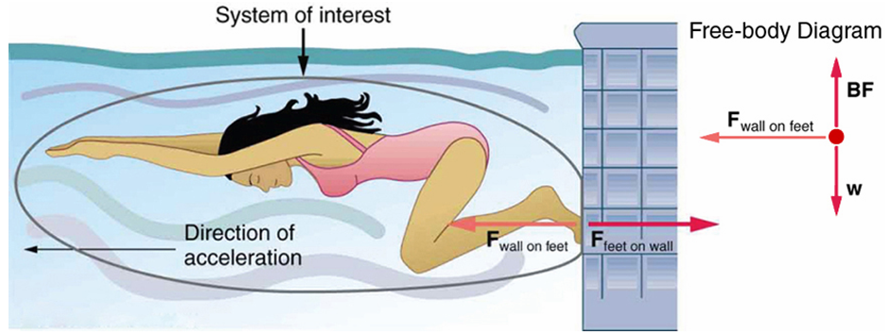

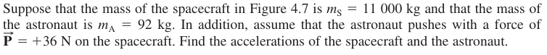
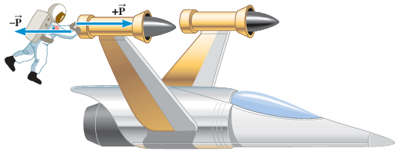

Identify the action-reaction pair of forces:
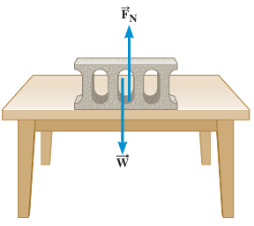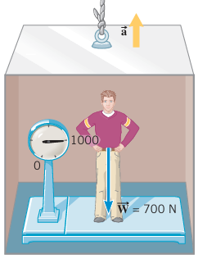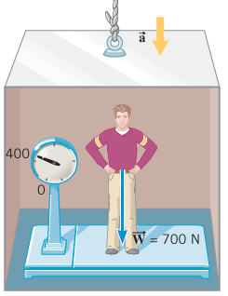

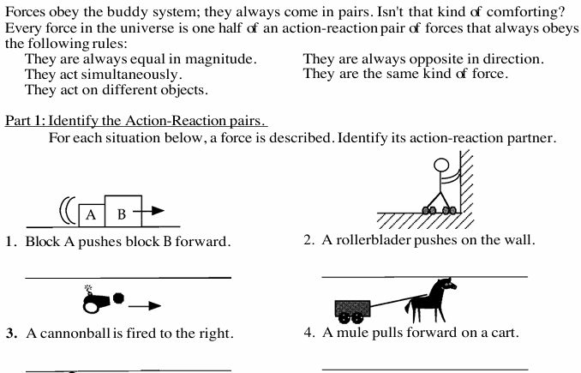
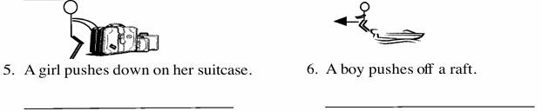

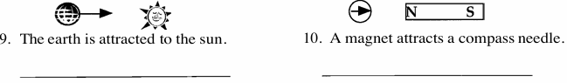
Action and Reaction Forces (Continued)

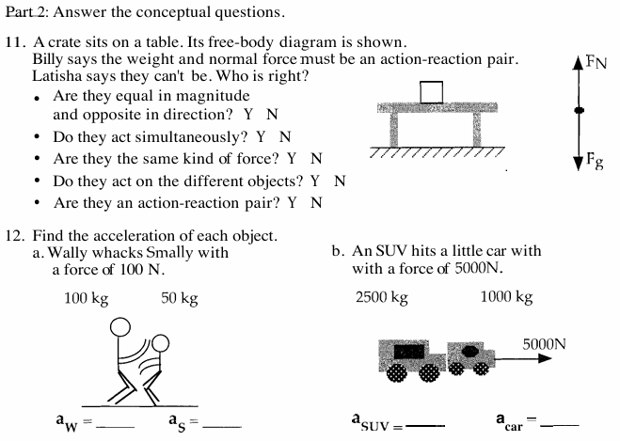

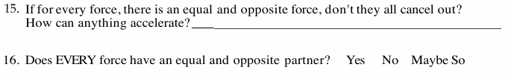

Two-Body System
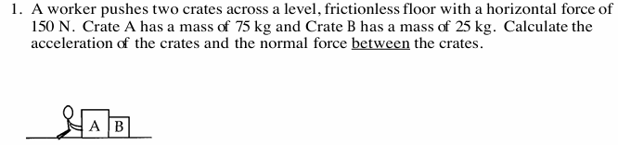

Two-Body System(Continued)

1. Internal Forces in a System: Action-reaction forces between the objects in the system
2. External Forces in a System: Forces exerted by objects from outside of the system
3. Newton’s Second Law for a System:
Net External Force = Total Mass x Acceleration of the system
